Do you have pain or stiffness in
your lower body?

Join Fit & Strong!
To improve the quality of your life
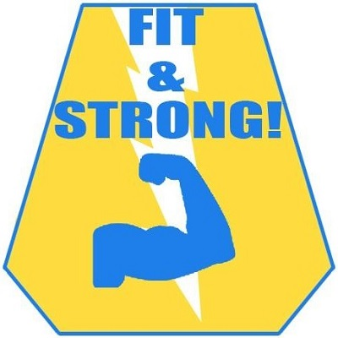
- Manage arthritis
- Exercise safely
- Decrease joint pain and stiffness
- Improve daily function
- Reduce anxiety and depression
- Develop and maintain an active lifestyle
Benefits of fit & strong!
Fit & Strong is an exercise/behavior change program for older adults with lower extremity osteoarthritis
Fit & Strong! Includes 60 minutes of exercise and 30 minutes of group discussion and health education

Classes will be held at (ADDRESS/LOCATION) on (DATES/TIMES)
For more information contact: (CONTACT INFO)

